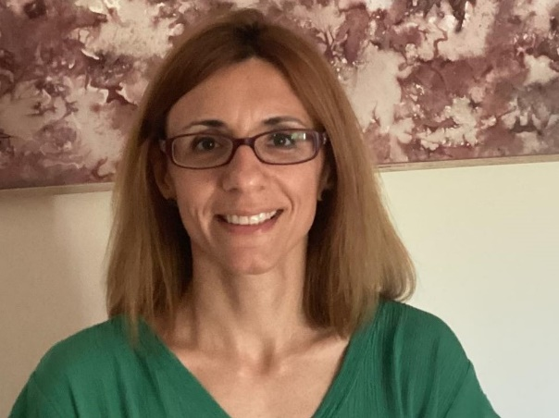
Meropi Kontogianni, PhD is Associate Professor of Clinical Nutrition at Harokopio University of Athens and member of the Research and Evidence Based Practice Committee since 2014. Her research interests focus on a) the contribution of dietary and lifestyle patterns in the prevention and treatment of NCDs and b) studying nutritional status in disease states. She has co-authored 97 scientific publications in peer-reviewed journals (>3,500 citations, h-factor 29) and 30 book chapters. She has been also involved in 18 research protocols funded by European and national resources, and she is an evaluator of research proposals in European Commission and other national funding entities.

