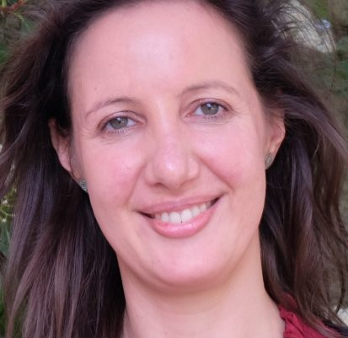 | Cecília Morais, Portugal  Why elderly care is so important for me:  A healthy diet and a good nutritional status are essential for the elderly to have a good quality of life. It is important to be able to work with this population group and help them to remain more active and healthier.
- Assistant Professor at Universidade de Trás-os-Montes e Alto Douro (UTAD)
- Integrated Doctoral Researcher at GreenUPorto – Sustainable Agrifood Production Research Center
- PhD in Food Consumption and Nutrition Sciences, Nutritionist BSc
- Registered Nutrition and Specialist in Community Nutrition and Public Health by the Portuguese Council of Nutritionists, Member of the Portuguese Association of Nutrition

Specializations or expertise:
My specialized area of research is nutritional status, food habits and consumption preferences of older adults. I also work in the area of Community Nutrition and Public Health, specially with the older populations but also in the area of Nutrition Education of children. I have been a nutritionist working in different areas of Nutrition and projects at the Faculty of Nutrition and Food Sciences but also in other working contexts, with experience from Clinical Nutrition to Food Service management. I am passioned about the study of the determinants of food consumption, nutrition education and how can food and nutrition contribute to a better quality of life and to the wellbeing of the populations.

Publications: ORCID - https://orcid.org/0000-0002-0821-1641

- de Morais, C.; Afonso, C.; Vaz de Almeida, M.D. Older People's Consumption of Alcoholic Beverages: Social Significance and Health (Book chapter); Food for the Aging Population: Second Edition, 2016; DOI: 10.1016/B978-0-08-100348-0.00006-8
- Chetty, A.A.; Prasad, S.; Pinho, O.C.; de Morais, C.M. (2019). Estimated dietary intake of nitrate and nitrite from meat consumed in Fiji; Food Chemistry; DOI: 10.1016/j.foodchem.2018.11.081
- Rocha, A.; Afonso, C.; Santos, M.C.; Morais, C.; Franchini, B.; Chilro, R. (2014) System of planning and evaluation of school meals; Public Health Nutrition; DOI: 10.1017/S1368980013001961
- De Morais, C.; Oliveira, B.; Afonso, C.; Lumbers, M.; Raats, M.; De Almeida, M.D.V (2013) Nutritional risk of European elderly; European Journal of Clinical Nutrition; DOI: 10.1038/ejcn.2013.175

