EFAD website (https://www.efad.org/our-community/education-committee/):

Photo:
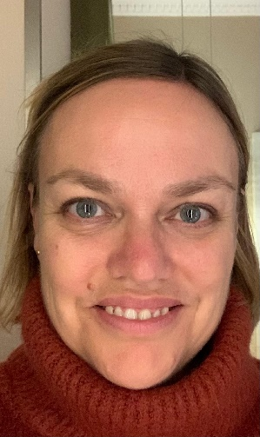

Name and function in committee:
Sofie Joossens
Committee member

Affiliation:
Lecturer at the UC Leuven-Limburg (BE), professional bachelor in Nutrition & Dietetics (an Education Associate member of EFAD).

More information:
Sofie Joossens is lecturer at the UC Leuven-Limburg (BE) in the programme of professional bachelor in Nutrition & Dietetics (an Education Associate member of EFAD). Teaching subjects include dietetics, epidemiology and evidence-based practice skills. Sofie coordinates practice placements and the bachelor thesis of final-year students and she is member of the programme committee.
Sofie is interested in a variety of areas of dietetic research and teaching especially around evidence based decision making. She appreciates and stimulates collaborations between HEI’s and the field. As a result, she was actively involved in the DIETS2 project as work package lead of work package ‘supporting Work based/Placement Learning’. This resulted among other in the development of the ‘Pedagogic Standards for Practice Placements’. Sofie is also member of the EBP Committee of the Flemish Dietetic Association (VBVD) and of both the Research and Evidence Based Practice Committee & the Education and Life Long Learning Committee of the European Federation of Associations for Dietetics (EFAD) and contributes in projects, publications and presentations tackling EBP, practice placements & education.
Sofie Joossens holds a B.S. degree in Nutrition and Dietetics (Rega School, Louvain), a M.S. degree in Dietetics and Nutrition and a Ph.D. degree in Medical Sciences from the Catholic University of Louvain (BE).

