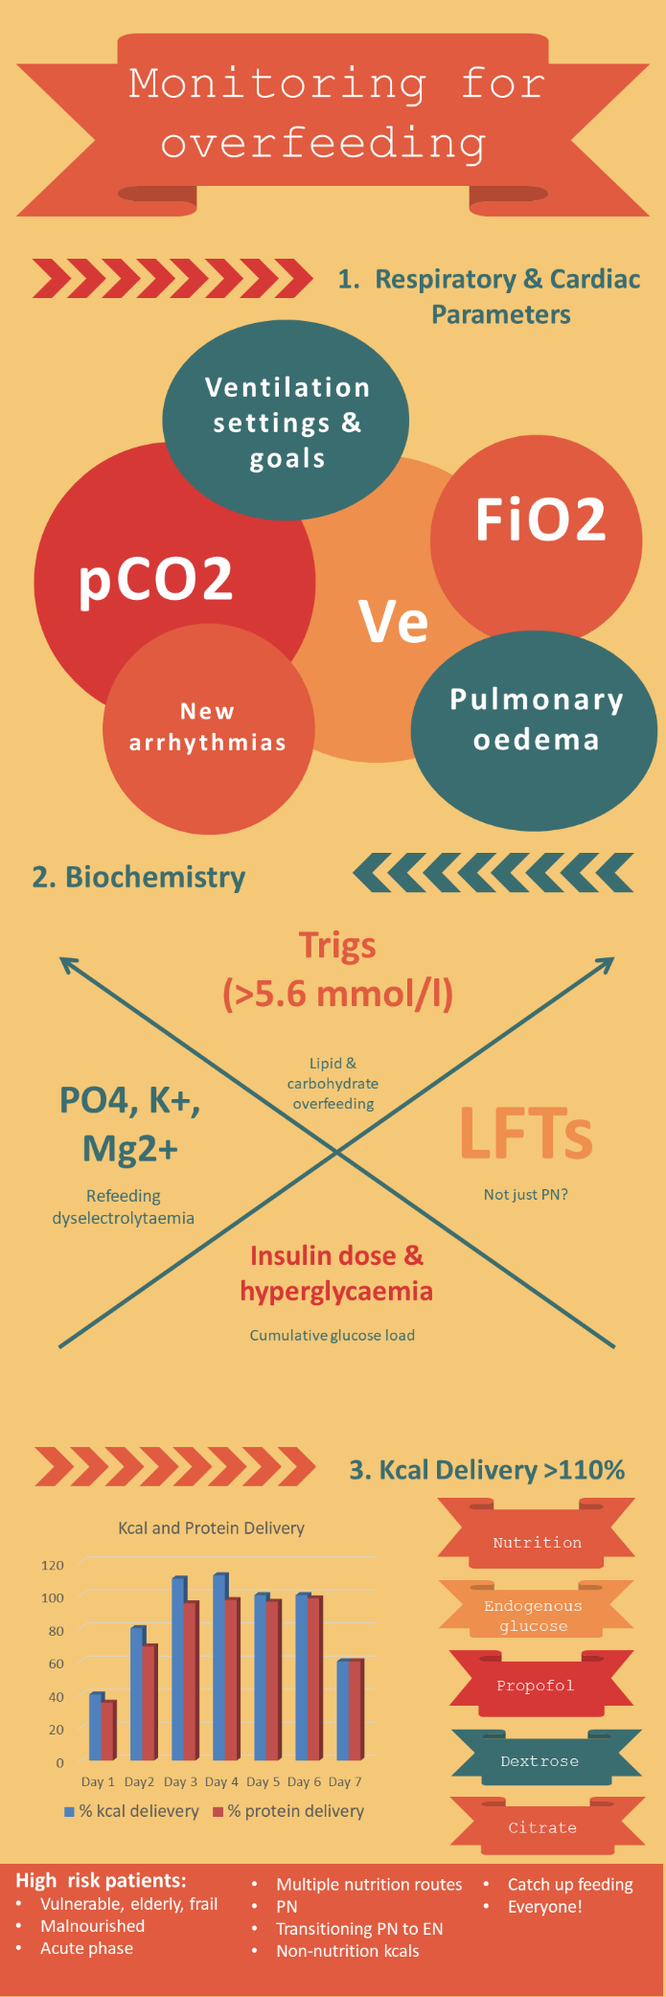

**Monitoring for overfeeding**

Overfeeding is harmful in critically ill patients. It is defined as providing >110% of estimated kcal requirement.

Signs of overfeeding:

1.Respiratory and cardiac parameters:

* Difficulties in respiratory weaning raised/rising pCO2 levels, increasing minute ventilation (Ve) and FiO2
* New pulmonary oedema
* New arrhythmias

May be difficult to determine whether occurrence of these symptoms is due to overfeeding or to COVID 19.

2. Biochemical parameters:

* Hyperglycaemia
* Raised/rising LFTs (EN and PN) – may be due to reasons other than overfeeding e.g. sepsis, antibiotic therapy, other medications, acute liver injury
* Raised triglycerides (EN and PN) – consider propofol rate also
* Refeeding dyselectrolytaemia

3. Kcal delivery

* Providing > 110% of kcal requirements
* Include non-nutritional kcal sources such as propofol, dextrose, citrate

**Monitoring for underfeeding**

Cumulative underfeeding is harmful to the critically ill. Record % kcal and protein delivery versus goal each review

Signs of underfeeding:

* Wt loss, appearance of wt loss, muscle/fat store depletion
* Deteriorating skin condition, pressure ulcers, wounds or drain/line sites
* Continuously not achieving estimated requirements
* Multiple feed interruptions