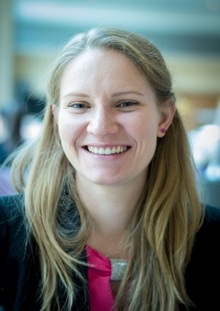 | Blanka Vékony, Hungary  Why elderly care is so important for me:  The older we are the more important it gets to stay healthy. The nutrition and role of the dietetics is one of the supporter factors which can help to reach healthy aging. I believe that awareness in our diet, usage of the opportunities in prevention and well selected treatment aid to achieve this goal. Keep in mind that sometimes minor changes in our lifestyle, diet can have a great impact of the quality of our health.
- Assistant lecturer at Semmelweis University Department of Dietetics and Nutritional Sciences
- Dietitian BSc, Nutritionist MSc
- Registered Dietitian, Member of Hungarian Dietetic Association

Specializations or expertise:
As a field specific assistant lecturer my tasks involves the presentation of age related dietetic factors and possible intervention methods. I regularly meet with elderly during my lectures or smaller workshops where the main focus is on prevention. Particularly how to achieve the status of „healthy aging” by the application of everyday nutritional practices. Among others I research the factors which influence the quality of life of the elderly, nowadays popular alternative diets and their effects on health.

Publications: https://m2.mtmt.hu/gui2/?type=authors&mode=browse&sel=10063845

- Health awareness as a determining factor in the development of whole grain products, Mihályi Z., Vékony B. 2021, New Diet, Vol 30,1, 29-31.
- Catering cookbook, Fehér F, Mák E, Molnár Sz, Tóth T, Vékony B, 2019, 246p. ISBN: 9786155855078
- About the most common food fermentations in general, Mák E, Vékony B, 2019, Catering, Vol 17, 6, 18-19.
- The appearance of fashion diets in case of dog holders and their pets, Vékony B., Bíró L., Mák E. 2020, New Diet, Vol 29,1,25-27.

