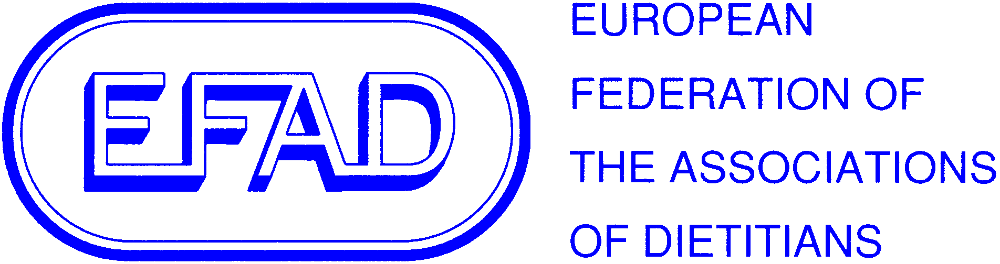

EFAD Meeting Report Template
A template should be completed and returned to secretariat@efad.org within 2 weeks of each meeting at which EFAD is represented.
What/Title | World Obesity Action Initiative Webinar
When/Where | Online webinar from London: 3-4pm BST 14th September 2016
EFAD representative | Hilda Mulrooney (ESDN Obesity)
Speakers/Attendees of interest to EFAD | Heather Flannery, Obesity PPM (www.obesityPPM.com)  Louise Codling, World Cancer Research Foundation international (www.wcrf.com)  Wendy Scinta, Obesity Medicine (www.obesitymedicine.org)  Hannah Brinsden, World Obesity Action Initiative (www.worldobesity.org)
Main messages | World Obesity Action Initiative:  - Image bank with unbiased, respectful, non-biased images freely available (www.imagebank.worldobesity.org). Supporting launch of Obesity Action Coalition image bank, link will be coming soon.  - Knowledge Portal - single resource with accurate facts & figures. Will be releasing new world obesity atlas within a few months with country profiles (www.worldobesity.org/resources/)  - World Obesity Day will be held on 11th October 2016, with theme of ending Childhood Obesity around the world. Theme chosen to build on work of WHO on ending childhood obesity (report published Jan 2016). Calling on national governments to take urgent action. What we can do to support this work:  - Support this by using social media (#WorldObesityDay)  - Visit the website -lots of information including resources eg infographics, provided including free SCOPE module (www.obesityday.worldobesity.org)  - Support thunderclap campaign to call on governments to meet their commitments. Sign up via website.  - Produce a press release.  - Write a letter to your Minister for Health.  - Hold an event in your community/workplace.  - Sign up for weekly World Obesity Day newsletter.  - Let World Obesity Action Initiative know what you do; they are producing a map of activities.  An advocacy toolkit and 3 obesity infographics (for 56 member countries) will be available on the website soon. In addition projected obesity prevalence for 2015 will be published soon in Pediatric Obesity, based on data from >200 countries worldwide.  ObesityPPM:  Contributing to reversal of obesity pandemic and founding champion of world Obesity Action Initiative. Involved in management of evidence-based treatments for those who are already obese. Involved in technical support of World Obesity Acton initiative and the World Obesity Day.  World Cancer Research Fund:  Link between 11 cancers and obesity.  WCRF NOURISHING database produced to pull together national policies in 3 key domains (food environment, food system & behaviour change) across 10 policy areas. Can search for different countries for any of these. Available on: www.wcrf.org/NOURISH  Obesity Medicine:  Pediatric Obesity Algorithm produced which will be launched in the United States shortly and then internationally. Covers preconception through to treatment including medical management.
Contacts/ links | See above.  Can watch the webinar using this link: https://attendee.gotowebinar.com/recording/6969271322642605314
Follow up | All should consider supporting World Obesity Day and using the range of resources available.
Benefits to EFAD | Link with global organisation to support action against a condition which is recognised as an international public health problem.  Can watch the webinar using this link: https://attendee.gotowebinar.com/recording/6969271322642605314

