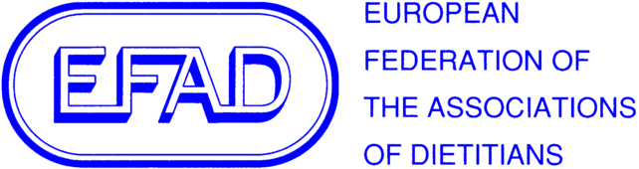 | The Voice of European Dietitians  Judith Liddell, Executive Director

The European Federation of the Associations of Dietitians

Executive Director:
Judith A. Liddell

Postal Address:

Ziegeleiweg 4
46446 Emmerich am Rhein
Germany

Phone+49-2822-68367
Fax +49 2822-68358
Email secretariat@efad.org
Web www.efad.org

Executive Committee:

Acting Honorary President
& Honorary Vice President
Annemieke van Ginkel-Res

Honorary Treasurer
Manuela Thul

Members
Pauline Douglas
Fiona McCullough
Elke Naumann
Tina Papoutsakis
Grigoris Risvas
Despina Varaklas

Registered Address:
Fisconti Tax Consulting
President Kennedylaan 19
2517 JK The Hague
The Netherlands

Kamer van Koophandel (Chamber of Commerce in NL) registration number:
40215656

European Commission Transparency Register Identification number: 99138006725-91

Secretariat of the EU Platform for Action
on Diet, Physical Activity and Health

12 June 2018

Dear Sir,

Re: Call by the High Level Group on Nutrition and Physical Activity to industry to continue action on food reformulation

The European Federation of the Associations of Dietitians (EFAD) fully supports the call by the High Level Group on Nutrition and Physical Activity to industry to continue action on food reformulation.

EFAD and our European Specialist Dietetic Network for Public Health Dietitians support the initiative calling on the industry to implement as soon as possible the commitments of voluntary reformulation adopted long ago.
We urge the benchmarks per food category to be developed as quickly as possible to facilitate the reformulation and we applaud taking into account the potentiality of national contexts to establish the threshold.

We are however, concerned that the great differences between the regions in term of the nutritional value of many (ultra-processed) products and their availability, will prolong the inequalities of the food environments between member states in the European region, especially regarding Trans Fatty Acids and the disparity on the content of sugars and Saturated Fatty Acids.

Yours faithfully

Judith Liddell
EFAD Executive Director

